H.T No
Regulations:
A17

Sreenidhi Institute of Science and Technology
(An Autonomous Institution)
Code No: 6C407 Date: 30-Dec-2022 (FN)

B.Tech II-Year II- Semester (A18) Special Supplementary Examination - December-2022
Electronic Circuit Analysis (ECE and ECM)

Time: 3 Hours Max.Marks:75

Note: a) No additional answer sheets will be provided.
b) All sub-parts of a question must be answered at one place only, otherwise it will not be valued.
c) Missing data can be assumed suitably.

ANSWER ANY 5 OUT OF 8 QUESTIONS. EACH QUESTION CARRIES 15 MARKS.

Bloom's Cognitive Levels of Learning (BCLL)

Remember | L1 | Apply | L3 | Evaluate | L5
Understand | L2 | Analyze | L4 | Create | L6

 |  |  | BCLL | CO(s) | Marks
1. | a) | Explain the low frequency response of BJT amplifier. | L2 | CO1 | [8M]
 | b) | The transistor amplifier,shown in the fig,uses a transistor having h-parameters as, V_{cc}=12v, hie=1.1K, h_{fe} =50, h_{oe}=25µA/V, h_{re}=2.5*10⁻⁴. Calculate current gain, input impedance, voltage gain, output impedance.  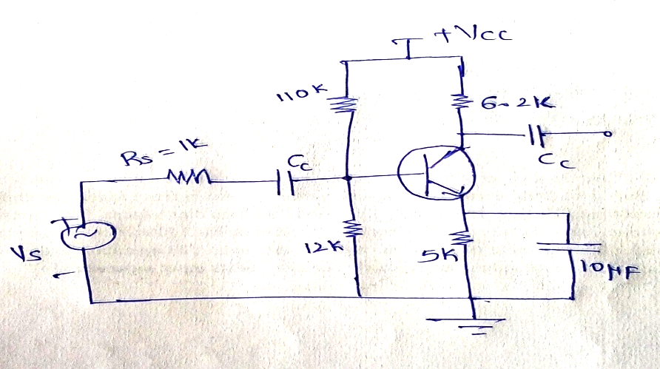 | L4 | CO1 | [7M]
2. | a) | A JFET common source amplifier with bypass capacitor has load resistance of 5kΩ, R_{D}=4kΩ, R_{G}=1MΩ, g_{m}=5mƱ, R_{S} = 1KΩ, µ=100. Calculate voltage gain, input and output impedances. | L5 | CO2 | [8M]
 | b) | Derive the expression for voltage gain of a common source amplifier without bypass capacitor. | L3 | CO2 | [7M]
3. | a) | Give the block diagram of a general feedback amplifier and state the function of each block. | L2 | CO3 | [8M]
 | b) | Discuss and explain the basic circuit of an RC oscillator and derive the conditions for the oscillations. | L3 | CO3 | [7M]
4. | a) | Write down the Classification of Oscillators. | L2 | CO4 | [8M]
 | b) | Draw the circuit diagram of a RC-phase shift oscillator using BJT and Derive the frequency of oscillations equation. | L2 | CO4 | [7M]
5. | a) | Draw the circuit for single tuned capacitance coupled amplifier explain its operation. | L1 | CO5 | [8M]
 | b) | Explain how the stagger–tuned design is superior to synchronously tuned design in the design of a multistage amplifier? | L2 | CO5 | [7M]
6. | a) | Draw the circuit of single tuned capacitance coupled amplifier and explain its operation. | L1 | CO6 | [8M]
 | b) | Explain the differences between single tuned and staggered tuned amplifiers. | L5 | CO6 | [7M]
7. | a) | Draw the High frequency model of a Transistor. Derive the relationship between high frequency and low frequency parameters. | L2 | CO1 | [5M]
 | b) | With a neat sketch explain about FET. | L1 | CO2 | [5M]
 | c) | Define frequency and amplitude stability of an oscillator. | L1 | CO3 | [5M]
8. | a) | Explain about classification of power amplifiers. | L2 | CO4 | [8M]
 | b) | Design any wideband tuned power amplifier with bandwidth of 30kHz to 1MHz. | L2 | CO5 | [7M]

-- 00 -- 00 –

